**USE TO AND DIDN’T USE TO WORKSHOP**

**NAME: FICHA:**

1. ***Complete the sentences with what people used to do and didn’t use to do before the invention of each item.***

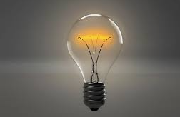

Before the invention of the light bulb

People

People didn’t

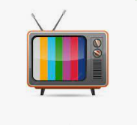

Before the invention of the television

People

People didn’t

People didn’t

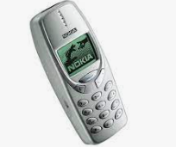

Before the invention of the mobile phone

People

People didn’t

People didn’t

Before the invention of the internet

People

People didn’t

People didn’t





Before the invention of the car

People

People didn’t

People didn’t



Before the invention of the digital cameras

People

People didn’t

People didn’t

1. ***“What things did you use to do when you were a child?” Answer this question in 150 words, write at least 8 negatives and positives sentences with used to and didn’t use to.***